Topic 2. Business model of digital business
For a digital business model to be successful, it must offer good content, customer experiences, and platforms. That being said, you don't have to strive for leadership in all three aspects.
Today's consumers want to be able to connect with a company anytime, anywhere. A recent survey found that 72% of consumers are willing to replace traditional channels with mobile apps if it allows them to be in touch with the manufacturer or seller of the goods and services they need. For companies, this is a compelling argument that they need to work to improve digital business models by interacting with customers in the digital space to create value through mechanisms such as websites and mobile apps. If your company is not offering digital experiences to consumers, many buyers, especially young ones, will go to competitors that offer online interactions, work in related industries, and start offering services similar to what your company offers.
To further complicate these changes, a good digital business model challenges the traditional physical business model , which assumes that shoppers should be delighted with places of sale (bank branches, bookstores, department stores, etc.) and people ( sales managers, insurance agents, etc.). The digital business model challenges the physical model in three main areas of operation: internal power, as the customer experience depends on who is “in whose hands” it is, from product-specific groups to multi- product customer experience departments ; business processes that need to be rethought in a new way to ensure their flawless functioning; customer data, which becomes an enterprise-wide resource, not just a single business unit.
Whether you are an online business, a established company, or a small business, you must refine your digital business model as you begin your search for the best way to communicate with customers online.
Electronic business models are always visible. They can quickly fail because the cost of moving to competitors in the electronic world is lower than in the physical world. And also because it is becoming easier to describe products electronically using pictures, objective data (for example, technical parameters of a mini-oven or management costs of a mutual investment fund) and third-party product ratings. Comparing the services of different companies using information search engines (for example, sites like Trip Advisor or Expedia Inc. when it comes to travel), where customers make their own ratings, as well as using social media is also quite simple.
To help leaders evaluate and improve their business model, we have developed a methodology that all organizations can use. In addition, we provide case studies from online and traditional companies such as Apple , USAA, and LexisNexis . We also set benchmarks and identified best practices in a recent survey. Summarizing the results of this survey, we found that the top 30% of companies with the best quality electronic customer service had higher profitability and revenue growth rates than competitors, by 8.5% and 7.8%, respectively.
From place to space
The importance of an effective digital business model has increased significantly after three trends converged at one point. The first trend is to digitize more and more business aspects : customer service, implementation of business processes, work with partners along the value chain. The second trend is the growing number of "aboriginal electronic technologies", that is, young customers and employees of your company (current and future) who need an excellent electronic interface to contact the company. The third trend is the beginning of the "era of the buyer", when consumers influence companies much more seriously, making various ratings (ranking by the number of stars on Amazon , polls, etc.) and leaving their comments about products and services on the Internet, Twitter and social networks.
Before the advent of the Internet, any business developed mainly "on the ground" in the material world: it was the physical world, which was based on various goods, a world focused on real interaction with customers. Today, many industries are moving at different rates into the digital space - intangible, service-based and focused on creating a consumer experience.
Take The Wall Street Journal, for example. In the “material” world, The Wall Street Journal creates content (articles, photographs, etc.), packs it into a print newspaper format (which has its own design, “atmosphere” and editorial style) and delivers it to consumers using a dedicated infrastructure (printing presses, trucks and newspaper distributors). Customer value is created by tightly integrating all of these components.
In the digital space, components such as content, packaging and infrastructure have transformed and differentiated themselves. The rapidly growing content is no longer solely owned by the publication itself: in the electronic world, The Wall Street Journal receives branded content from other sources (such as Reuters) and, in turn, provides its content to partners who offer it to their customers. Packaging has been transformed into a single electronic format, offered to customers on a variety of devices. The infrastructure has evolved into a combination of internal and external electronic platforms, some of which are controlled by The Wall Street Journal and some not (for example, The Wall Street Journal can be viewed on a smartphone, computer or TV screen from anywhere in the world). Customer value today is generated by the modular combination of these components, with different offers often being created for different customers.
Content, customer experience and platform
The digital business model has three components: content, customer experience, and platform .
Let's take a look at Amazon 's digital retail business model . Content offered by Amazon includes digital products (films, software, etc.) as well as information about physical products that Amazon itself or resellers sell . However, many digital products threaten the status quo of Amazon itself and other companies. For example, in May 2011, e-book sales on Amazon surpassed regular book sales for the first time.
By customer experience, we mean the experience people have when they shop online for your company's products or services, whether digital or physical. The Amazon consumer experience is shaped by the site and digital business processes that affect the customer (shopping cart, payment methods, delivery messages for a purchased item, or email confirmation of payment). This experience also depends on the customer- generated piece of Amazon content (ratings, product reviews, and sophisticated tools such as site searches, purchase history, and special recommendations).
The platform is a coherent system of digitized business processes, information data and infrastructure.
The platform has internal and external components, and it must ensure the delivery of not only digital content to buyers , but also physical products. Amazon 's internal platforms include customer data as well as all business processes that do not involve customers - customer data analytics, human resources, finance, and merchandising . External platforms include phones, tablets, or computers that customers use to research and purchase products, and Amazon's telecommunications network and partnerships with postal and courier services (such as UPS) that deliver physical products and send delivery text messages to customers. All of these external platforms are clearly integrated with Amazon's internal platform .
To achieve economies of scale, digital business models need to design and use the same model across all parts of the company. If there are no such common platforms, the IT department will have to develop new solutions for each case, creating a chaotic set of systems that respond to specific customer needs, but are expensive, unstable, and not suitable for use throughout the enterprise. Moreover, when a customer has a fragmented experience of each individual product, they are much less satisfied than when they get a single impression of different products.
How LexisNexis Improved Its Business Model
The experience of LexisNexis , one of the leaders in the legal information market with a turnover of $ 2.3 billion, is an example of effective business model improvement. The fact that the activities of LexisNexis is becoming increasingly "digital" can be judged on the report of the parent company Reed of Elsevier , according to which the share of revenue LexisNexis of electronic content and digital tools increased from 22% to 63% in ten years. The company's management predicts that in the near future, digital will generate almost 100% of its revenues.
As legal information goes digital, it becomes more accessible. Accordingly, the importance of companies such as Bing and Google , which, by providing information such as legal contacts, public documents and case law data, allows you to work without intermediaries. Governments are also converting more and more documents into electronic form, making them searchable and easier to access.
In response, LexisNexis has invested in exclusive content, a better customer experience, and a more flexible platform.
Creation of unique content
LexisNexis has diversified its content to make it more interesting for lawyers. The company continues to provide access to public records and case information in an effort to further simplify searches. But to create unique content, LexisNexis has built a system of relationships with experts and renowned lawyers who express their opinions on various aspects of legal practice (intellectual property, bankruptcy, constitutional and tax law, etc.). These comments are regularly updated and used with enthusiasm by lawyers.
LexisNexis has also increased the volume of user generated content . The company has entered into agreements with 30 of the best law firms in the United States to provide expert commentary through LexisNexis channels . The company has signed similar agreements with leading American bloggers and lawyers. The goal of all these innovations is to create unique content that cannot be obtained from other sources.
How to improve and measure customer experience
Company LexisNexis lot invested in improving the consumer experience. Market research based on focus groups and surveys no longer works, so LexisNexis has assembled a group of anthropological scientists who interact closely with consumers to identify their unmet needs. Researchers communicate with consumers, ask them to describe the most annoying moments of each day, identify the most frequent requests and suggest the best solutions for them.
This deep, customer-focused innovation is essential to the LexisNexis business . For example, through this process, changes were made to the strategic roadmap for LexisNexis' mobile services . Initially, the strategy for the development of mobile services was intended to provide full access to LexisNexis services from mobile devices. However, a pilot study found that consumers want to use mobile devices to solve questions that require quick answers (such as searching for legal terms, analyzing codes and precedents), and to solve each question using a dedicated application. LexisNexis has developed over 15 of these targeted applications, with over 81,000 downloads in its first year.
LexisNexis has also begun to use “ trackers, ” software that tracks consumer activity (including page views followed by purchases), as key points of customer interaction . Trackers are used to quickly assess customer satisfaction; they allow you to identify and solve the problem even before it affects the relationship with the company as a whole, and reduce the company's dependence on sociological research.
Developing a flexible global platform
On the new LexisNexis platform , called Lexis Advance , all technologies and business processes are completely updated. Among other things, it offers a higher level of consumer experience and includes tools such as My Workspace (an electronic file for storing, organizing and accessing legal research), advanced filtering before and after searches, visualization of links and their verification, and also new opportunities for links (for example, court cases and legal codes may contain links to public documents , company reports, sentences and much more). Search capabilities today include both consumer content and Web and LexisNexis content , and are tailored to the preferences of each individual user (for example, a lawyer in New York is most likely interested in cases that were tried in a court of the second district, and not ninth).
The new platform was developed in such a way that it could be used on mobile devices, and the mobile applications themselves were well synchronized with the full version. In addition, the platform can be used all over the world because of its "smart content" and the flexibility to easily add new applications.
Empowering the digital business model
Investments in exclusive content, customer experiences and an integrated platform have allowed LexisNexis to enter exciting market segments. One of them is the segment of small law firms (from one to fifty employees), which employ about half of all American lawyers. As a rule, small firms do not want and cannot buy services of the level that large law firms can afford. LexisNexis has added content and services of interest to small firms, such as targeting and securing leads, building websites, and rating clients and fellow lawyers. For networking, the small business unit doesn’t use experimental research, but trial and error — new offerings are rolled out in multiple markets, and then the best ones are distributed to customers. The basic LexisNexis pricing model is based on an all-inclusive subscription. The company also offers subscriptions to some of the content, either geographically or by type of legal practice. There is also a payment option for using the company's services.
Following LexisNexis' lead , companies need to identify and invest in the primary sources of competitive advantage for their digital business model - content, customer experience, platform, or a combination of both. Company LexisNexis has decided to refine its model in all three directions to create the leading digital business model in the industry that can be used globally and to adapt to adjacent markets. But should every company strive to become a leader in its industry in all three areas?
What is your digital source of competitive advantage?
We looked at successful digital business models from companies such as Amazon , Apple , Bloomberg , Banco do Brasil , DirecTV , ING Direct , Google , Netflix, and USAA, and analyzed the results of a survey of 139 companies. For a digital business model to be successful , a company needs good content, customer experience, and electronic platforms. But should the company be the best in each of these areas? We don't think so - at least not yet.
Consider Apple as an example . In 2012, the company shipped 125 million iPhones and sold more than five million iPhone 5s in its first weekend after launch. In the first quarter of 2012, iPhones accounted for 9% of total mobile phone sales - and a whopping 73% of total industry revenue. The company has created a huge amount of content - the number of active applications for the iPhone has already exceeded 700 thousand, and the total revenue from the sale of applications is about $ 5 billion per year. In 2013, the revenue of Apple from selling applications, music and e-books accounted for $ 13 billion in consumer experience. A p ple - from easy-to-use interface iTunes to other aspects of the magic of the brand Apple , all the products that are perceived as cool and interesting - has become a reference point for all competitors. But it is the combination of the company's electronic platforms - great physical product design, the development of the iTunes platform, and the integration of operating systems and devices - that are most difficult for other companies to replicate.
Apple 's competitive advantage today is its consumer experience and platform, not its content. What's more, Apple's consumer experience and platform allows other companies to create most of the content. Company Apple has managed to create a new type of customer experience - a mobile application branded packet access to new content. And it changed consumer behavior, spending more time using a mobile app (like The Wall Street Journal 's iPad app ) than using a web browser. This trend has far-reaching implications that will impact how we build effective digital business models and develop great mobile apps.
Evaluating the effectiveness of content, customer experience and platform
To better understand the various industry digital business models , we surveyed a range of companies and measured the performance of their content, customer experiences, and platforms. We have collected answers to eight to nine questions on each of the three aspects of the digital business model (content, experience, platform), based on them, creating a basis for assessing performance.
The highest indicators of overall efficiency were noted in the IT-industries (software and IT services), the lowest - in the energy, mining and healthcare industries. Interestingly, the companies with the best financial results in each industry also demonstrate higher performance in the digital business model . For example, financial companies ranked in the top third in financial performance had ratings for content, experience, and platform, respectively, 29%, 35%, and 26% better than companies in the worst third.
But where do you start building an effective digital business model? It depends on your strategic goals. If your goal is to generate additional revenue from the electronic segment, you need to improve digital content (information and / or products) and everything related to it. If your goal is to cross-sell and increase revenue per customer, then you should focus on improving the customer experience. If your goal is flexibility and efficiency, you need to focus on building electronic platforms.
USAA e-business model
For most offline businesses , building an effective e- business model involves many parts of the organization working together and sometimes “surgery”. Let's look at USAA - a company in San Antonio, Texas, which provides financial services. The company began its activity in 1922 with the sale of insurance policies to the military. Today the company has several branches and eight million customers, and the content is a complex collection of financial products and services. USAA is considered one of the leaders in consumer experience in its industry. USAA itself also believes that it is thanks to the consumer experience that the company has achieved success. Therefore, USAA reorganized its sales channels and call centers, consolidating them into a single organization that focuses on important events in the lives of customers, not products. Typical examples of important events are buying a house or car, having a baby, or getting married. When USAA customers visit the company's website (or call the company), they can select an “important event,” and then they will be presented with a comprehensive set of products associated with that event. To manage this process, the company introduced the position of Executive Vice President, Customer Experience, who reports to the president and has over 12,000 customer service employees. To generate content and customer experience, the company uses a single file with customer information and a common platform (infrastructure, information services and applications). All this allowed the company to achieve impressive results. We consider the quality of USAA products and services to be very high, but the main competitive advantage that has ensured its success is customer experience. Ultimately, USAA restructured its digital business model - and indeed its entire business model - to deliver a high-quality consumer experience.
Travel from "place" to "space"
The transition from “place” to “space” is faster in some industries than in others. For example, in this sense, the media are leading - and the way this industry fought for the right to get paid for its content should sober up those industries that are only now embarking on the journey from "place" to "space."
The retail and financial services market is not far behind the media. In each of these industries, there are players with significant investments in physical sales channels (for example, Target Brands Inc. ), as well as newcomers competing mainly through electronic sales channels (for example, Amazon ). In a rather poignant article in The Wall Street Journal , Target was irritated when it was used as a kind of showroom: consumers browse the products on display in its stores and then buy them at a lower price from companies that do not incur infrastructure costs such as Target . To counter this, Target has asked vendors to develop unique products that will make it harder to compare prices using barcodes and find similar products online.
Where exactly is your industry and your company on the path from “place” to “space”? Now is the time to rethink the digital business model. As we have seen, there is a turning point on the path from printed to electronic books, after which the transition to "space" is accelerated, and this is very difficult to resist. Just look at the sunset of the classic bookstores. Other industries will follow this path, too, at different speeds, which will depend, in part, on factors such as industry regulation, product complexity, and the ability to digitally offer it. Even in industries such as healthcare, which traditionally involve physician and patient physical interaction, there are more online services: doctors consult patients using email, monitor them remotely, and insurance companies create online claims for reimbursement of insurance claims. more and more introducing self-service. The shift from “place” to “space” and the need to develop a digital business model are common not only for the consumer market, but also for the B2B market, as we have shown with the example of LexisNexis .
To help you develop and evaluate your company's digital business models , we invite you to reflect on the value of your current content, customer experience and platform (by business unit and / or major customer segments), and the value you expect to receive in three years. Ask colleagues to evaluate your digital business model. As you ponder the future value of content, experience and platform for your business, we ask you one final question: Does your budget for next year reflect the importance of content, customer experience and platform? How do you manage it? As your customers and business move from “place” to “space,” you need to lead the process of improving your digital business model .

Three Pillars of a Digital Business Model
The three pillars of a digital business model - content, customer experience, and platform - create a compelling value proposition for the customer.
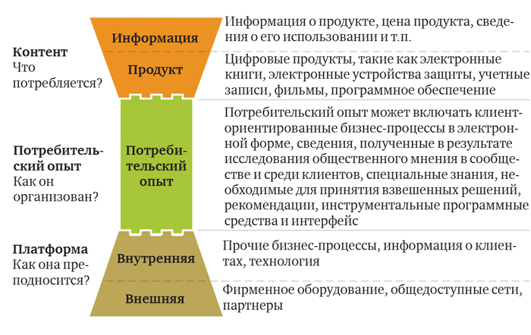
LexisNexis Digital Business Model
Deciding to modernize its digital business model, LexisNexis has improved all three aspects of the model - content, customer experience and platform.
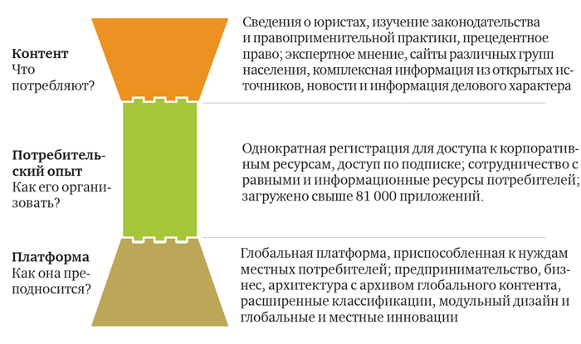

Content, customer experience and platform performance by industry
We surveyed companies across industries to measure their content performance, customer experience, and platform. Efficiency was assessed on a ten-point scale (1 point - "complete ineffectiveness", 10 points - "highest efficiency").
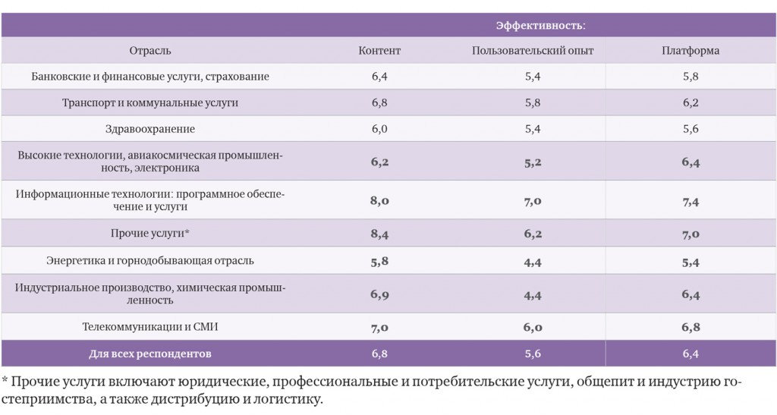

Assessing the digital business model
Try answering the following questions to help you and your colleagues prioritize the process of improving your e-business model:

Digital business models have 4 characteristics
Confusion often arises between digital offerings and digital business models . In general, the digital offering is just an addition to existing services or products, such as an app for your product, a chatbot for contacting support, or an interface for managing a product. Digital business models , on the other hand, have certain characteristics that help differentiate them from digital offerings:

1. Value is created through digital technology
When the value proposition of the service offered is (exclusively) digital-based, then we have one big metric for the digital business model. Amazon, Alibaba , Facebook , Google , etc. would not have been possible without the use of the Internet.

2. Digital business models are new to the market
One of the best examples is the difference between digital offerings and digital business models . When you read energy consumption data through the app, it is your electricity supplier's digital offering. When you order transport through an app that matches your driver request, then it is a digital business model.

3. Digital purchases and distributions of customers
To become a client and use the service, you need to use digital channels. Digital business models are sometimes based solely on digital channels. This is especially important for business models that rely on early adoption ( freemium ) or marketplaces (for example, Amazon advertises when searching the Internet).

4. USP is created digitally
When a customer is willing to pay for your services and offerings that are created on the Internet, then this is a strong indicator of a digital business model , as customer value can be digitally created as well as monetized .

Different types of digital business models

1. Free model (Special model)
Everyone knows the "free" business model, as it is used by two of the most famous companies in the world. Google , like Facebook , are good examples of how to use an ad- supported and “free” business model. The idea behind this business model is to offer the service for free and the user becomes the product that is sold. In the case of Google and Facebook , each user who uses the services provides valuable information about themselves. With this data, you can easily display ads that businesses can buy and target specific users.

2. Freemium model
Especially in the software world, this is one of the most common digital business models. Users get free access to the basic version ( Free ) of the product, which is mostly limited in some respects. If the user wants to use more features or resources, he has the option to upgrade to the paid version ( Premium ).
Spotify is a great example . Everyone can use the service for free (and receive advertising), but if you want more features and higher quality, then you need to pay a monthly subscription. It is also a great example of how different business models can be mixed.

3. Model on request
Similar to the Access-Over-Ownership model, there is also an on-demand business model. In this case, it is not a physical product that you own, but a virtual product or service.
On-Demand works, for example, through online video stores where you get the right to consume video for a specified period of time ( Amazon Video , Apple TV +, etc.).
We also see the model on demand in Gigaeconomics . This is an example where you book a consultant and you get automatic payment based on how long you need help. ( Upwork , UpCounsel , Fiverr , etc.)

4. The e-commerce model
One of the earliest and by far the most successful companies to sell physical goods through an online store and e-commerce was Amazon . It is also the most famous business model on the web today, and you can buy almost anything online.
Unlike the market model, which is also Amazon today , pure e-commerce models are based on a one-way sales approach. The company sells its own shares to buyers.

5. Marketplace model (Peer-to-peer, two-way marketplace)
A two-sided market is something we see quite often on the internet. Sellers and buyers use a third party platform to trade their goods and services. This marketplace can include services ( Uber , Upwork , etc.) or also products ( eBay , Etsy , Amazon ).
The biggest problem with this business model is its complexity and dynamics. If you don't have sellers, you will never attract buyers, if buyers don't find sellers, you will lose them. Thus, a two-sided platform must carefully scale supply and demand at the same time in order to maintain attractiveness to both sides.

6. Ecosystem model
Digital ecosystems are one of the most complex, yet most powerful digital business models to date. Ecosystem orchestras such as Amazon , Alibaba , Google , Apple , Tesla and many others use clients with different services on different platforms. With knowledge and data, they can attract new customers thanks to the “ salesperson isolation ” effect that their ecosystem creates.
Just think about what services you use at Google , Apple , Amazon , Alibaba , etc., and how difficult it will be to leave their digital ecosystem. The peg effect is also an important factor for future earnings. But you don't have to be an ecosystem orchestra, maybe you are a user of ecosystems or supply modules to the ecosystem. A good example of a modular provider is PayPal , which provides seamless payment for many different digital business models and ecosystems.
Further information: What is a digital ecosystem? - Understanding the most profitable business model

7. Ownership Access Model / Sharing Model
It's all about sharing, but in a business sense. This system allows you to pay for a product, service or offer for a certain amount of time without having real ownership rights. This could be a car rental (such as Zipcar ), an apartment rental (such as Airbnb ), or even industrial equipment.
It has been one of the most disruptive business models in terms of its impact on ownership and the resulting income. The car could suddenly become a source of income instead of just generating expenses.

8. Model of experience
Adding experience to products that would not have been possible without digital technology. One example is Tesla , which has brought a whole new digital experience to the automotive industry by adding digital services and even a digital ecosystem to its cars, which is currently the main engine for their business model.
Another example of an experience model is also combining different experiences together and creating a new customer-centric ecosystem.

9. Subscription model
We all know Netflix or Office 365. These products are good examples of the classic subscription model. There the user gets access, updates, services, etc. on a monthly / yearly basis. The subscription model is especially used for content, software, and membership.

10. Open source model
Firefox is one of the most successful open source examples. The software is free to download, free to use, and open to the worldwide community to contribute. Because it is free and many people contribute, it spreads quickly and usually also gets a lot of (free) resources to improve the software. Business model lies at the heart of Firefox , generates fees and partnerships with search engines.
Open source itself is not necessarily a business model, as you may not be able to use software for a sustainable business model. Red Hat distributes Linux-Distribution for free and then makes money from training, services and software hosting.

11. The hidden model of income generation
Sometimes income is not always visible to customers at first glance. Other value streams are possible through the collection and analysis of data. As we saw with Mozilla , where the open source browser generates royalty revenue, including various search engines, we know that there can be hidden business models behind platforms and digital services .
It is very important for companies to realize what their potentials are and whether there are further opportunities to use the existing business model with another to generate additional income. But hidden revenue generation can also backfire, especially when dealing with data and with ignorant customers. Cambridge Analytics was an excellent example of such a pullback that had serious consequences for both companies.

Choosing the Right Digital Business Model
It's always an answer where you don't have a direct answer. So what is the best / right / most profitable / most successful business model? - Well ... IT DEPENDS
Each company must see what offers it wants to have and where it wants to optimize them. Two-sided markets are extremely complex and take longer to grow, Freemium is widely adaptable and can be combined with ad-hoc business models as we've seen with Spotify , and digital ecosystems can be the most complex and risky business models as they involve massive investments. large user base; and orchestration of many partners and threads.
When thinking about new business models, it's always good to think about the customer and the unique value proposition you want to have. Be careful not to overdo it and better keep it clean and light, rather than involving too many business models at the same time.
Especially for platforms, markets and digital ecosystems, it is important to note that immediate monetization can hinder growth and lead to a gap between supply and demand. Sometimes digital business models need a critical mass and a critical base to use the monetization model, and therefore require a lot of time and investment before they can start generating revenue. This is why there are two different strategies:
Therefore, for earlier / faster monetization, it is better to consider Freemium , E- Commerce or subscription models . They are simpler as the supply side is already fixed / can be better controlled, you can generate direct revenues and can only focus on generating the demand side.
Business models that are more long-term and focused on network effects are usually two-way platforms, valiant marketplaces, and especially digital ecosystems. They must grow for a long time before monetization makes sense, and therefore have a long-term funding gap that needs to be overcome. But in the long run, they can financially outperform other businesses as they exploit the network effect, call it the “ winner take all ” effect , to dominate the market due to size and reduce the entry of new competitors as they first need to catch up. (Example, Facebook and Google + - Facebook already took over the market and Google had no chance with their social media platform due to the network effect).

